Customer Name : Date :

E- Mail ID : Mobile # :

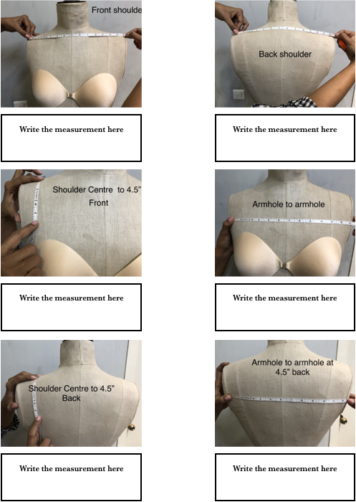

- ……………….

- ……………….

- ……………….

- ……………….

- ……………….

- ……………….

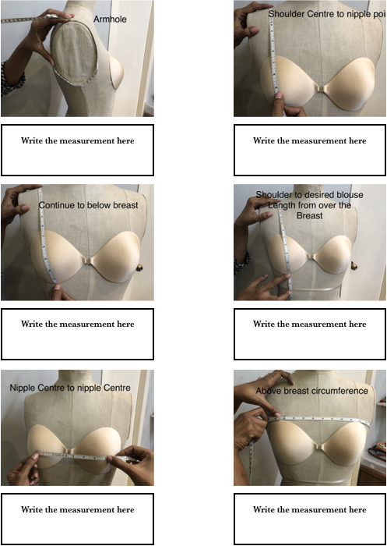

- ……………….

- ……………….

- ……………….

- ……………….

- ……………….

- ……………….

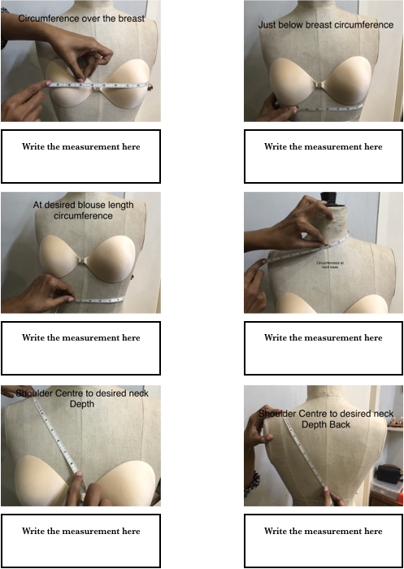

- ……………….

- ……………….

- ……………….

- ……………….

- ……………….

- ……………….

Additional Measurements for Blouse

Bicep : …………….

Desired sleeve length : …………….

Sleeve loose at desired sleeve length : …………….

Styling Request:

Drag & Drop Picture here

